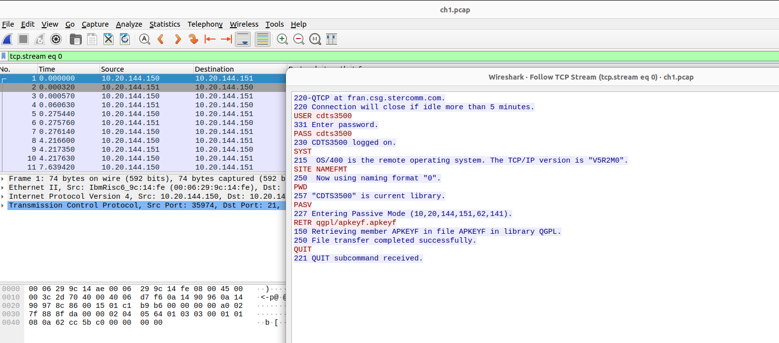
Every one should try follow TCP stream below analyze ->follow

